|  |  |  |  |
| --- | --- | --- | --- |
|  | Bansilal Ramnath Agarwal Charitable Trust's  Vishwakarma Institute of Information Technology  **Department of**  **Artificial Intelligence and Data Science** | | |
| Name: Siddhesh Dilip Khairnar | | | |
| Class: SY | Division: B | | Roll No: 272028 |
| Semester: IV | | Academic Year: 2022-2023 | |
| Subject Name & Code: ES22201AD: Probability and Statistics | | | |
| Title of Assignment: Variance, standard deviation, quartiles, inter quartiles in R | | | |
| Date of Performance: 03-04-2023 | | Date of Submission: 10-04-2023 | |

**ASSIGNMENT NO. 6**

**Background Information:**

1. Variance: Variance is a measure of how spread out a dataset is, calculated as the average of the squared differences from the mean. A higher variance indicates a wider range of values in the dataset. In R, you can calculate variance using the `var () ` function.

2. Standard deviation: Standard deviation is a measure of how spread out a dataset is, calculated as the square root of the variance. A higher standard deviation indicates a wider range of values in the dataset. In R, you can calculate standard deviation using the `Sd () ` function.

3. Quartiles: Quartiles are values that divide a dataset into four equal parts. The first quartile (Q1) is the value below which 25% of the data falls, the second quartile (Q2) is the median of the data, and the third quartile (Q3) is the value below which 75% of the data falls. In R, you can calculate quartiles using the `quantile () ` function.

4. Interquartile range (IQR): The interquartile range (IQR) is the range between the first and third quartiles and represents the middle 50% of the data. In R, you can calculate the IQR by subtracting the first quartile from the third quartile.

**Program and Output:**

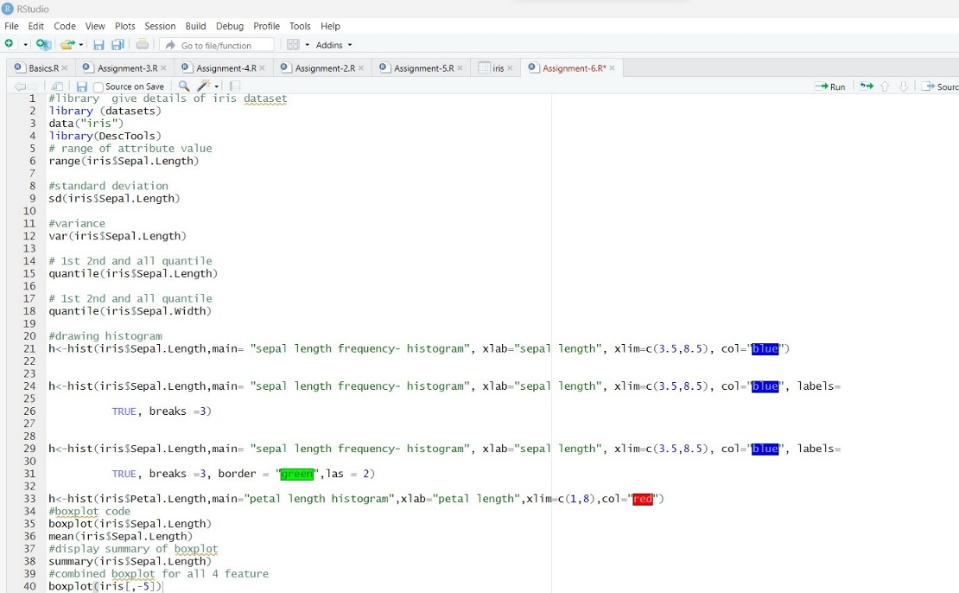

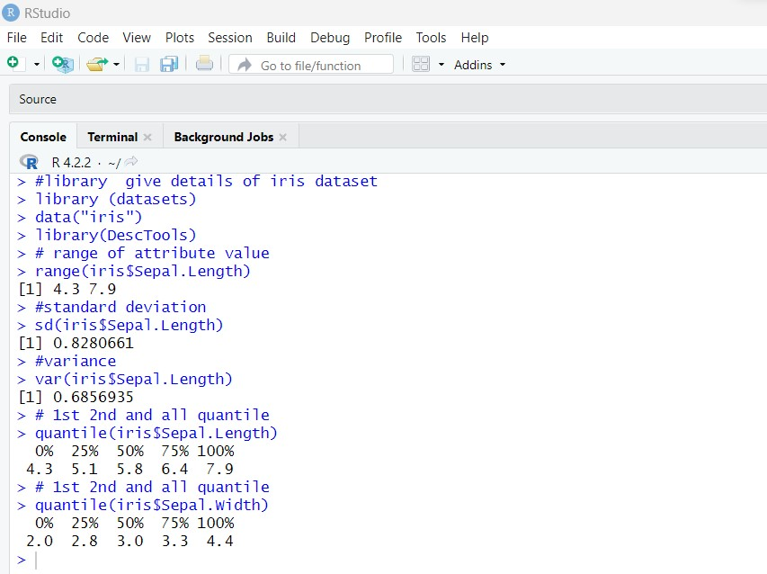

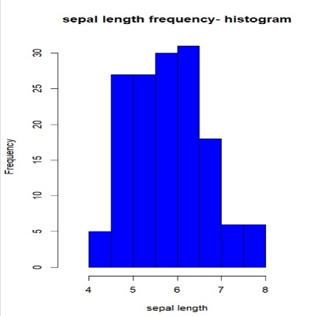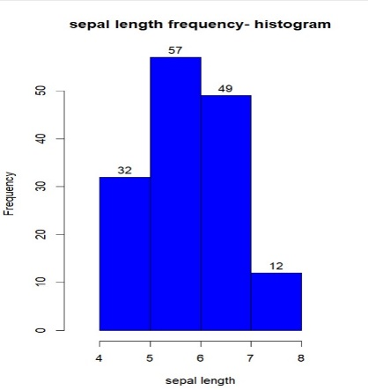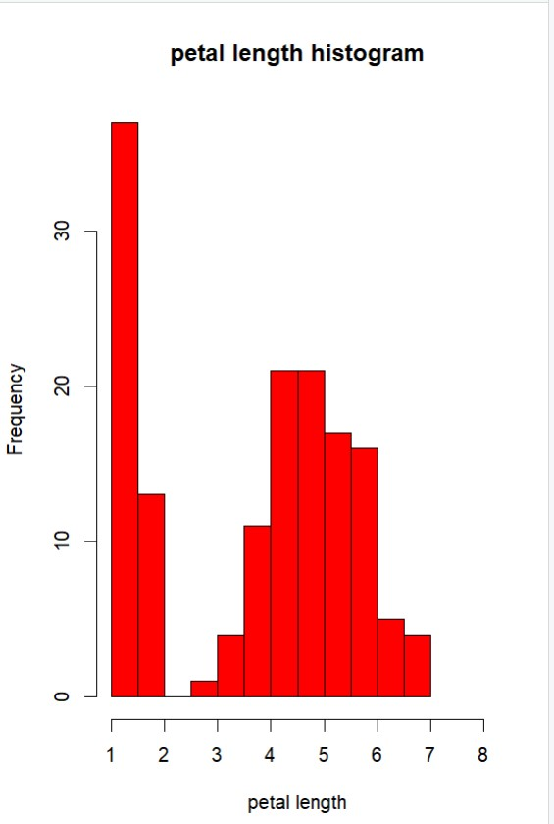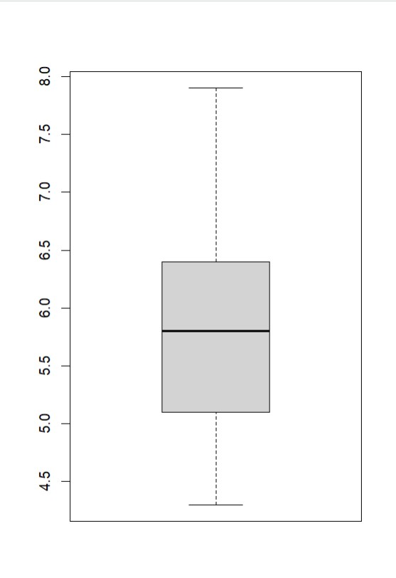

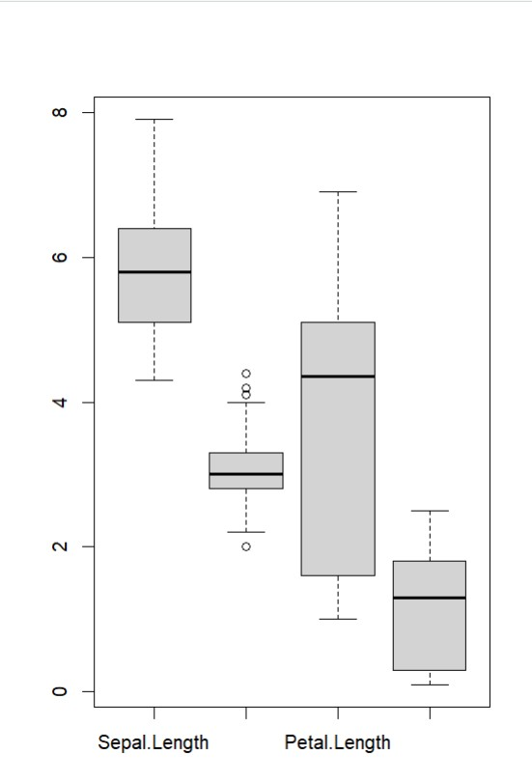

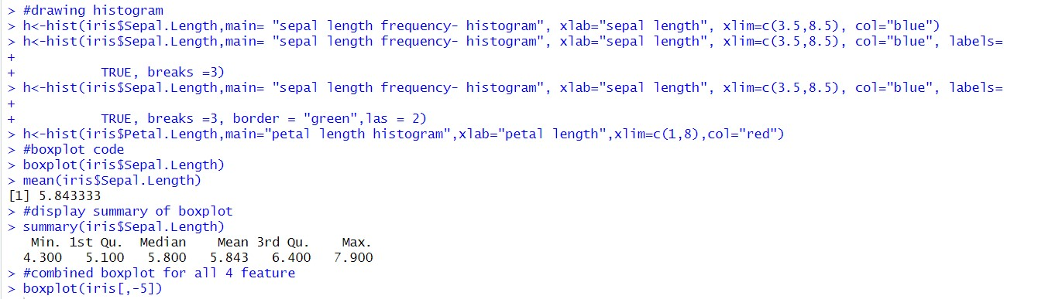

**Conclusion:** Hence, in this assignment we’ve learned and implemented various variability measure in R Studio